**Lab Objectives:**

1) To become familiar with the Windows OS environment

2) To become familiar with the hardware of your computer

**Preamble:**

Windows is the most common operating system used for PCs. It is essential that you familiarize yourself with the basic functionality of this OS.

It is necessary that you are aware of the hardware in your computer. While the operating system usually takes care of the complexity of managing the hardware of your computer system, knowing the hardware helps when you have to:

1. Install an operating system
2. Upgrade your computer system
3. Diagnose and repair problems in your computer system

**Lab exercise:**

1. Familiarize yourself with the following basic tasks specific to Windows operating systems *[ask your instructor if you have problems]*:
2. Copying/ pasting a file [select a file, right click> copy**;** go to the directory to paste into, right click > paste]
3. Creating a new file [hint: right click > new > file type]
4. Creating a new folder [hint: right click > new > folder]
5. Deleting a file [hint: select a file, right click > delete]
6. Finding how to find Windows help [hint: click on Windows *Start* button, and then on Help and Support, explore what kind of help is available]
7. To check the hardware present in your computer, Right click on *My Computer* and then click on *Properties (See Figure 1),* note down the specifications of the PC you are working on in the *General* tab (shown by default).

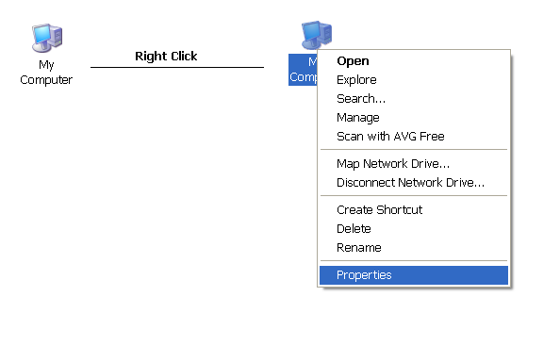

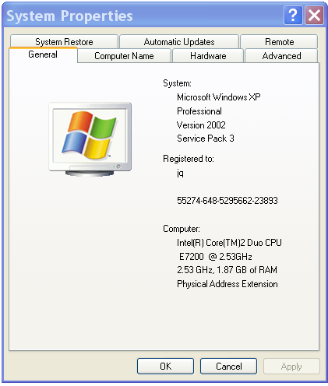

1. What is the Operating System being used? (write complete details)
2. What Service Pack is installed?
3. What is the CPU name?
4. What is the clock speed of the computer’s CPU?
5. What is the amount of RAM present?
6. Click on the *Computer Name* tab.

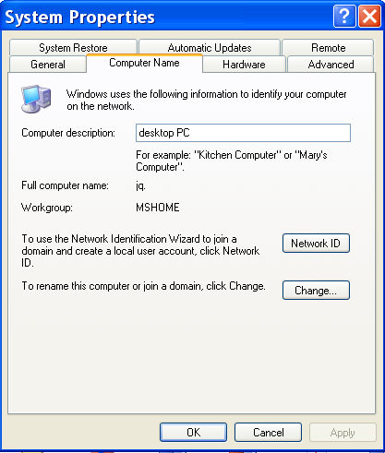

1. What is the computer’s description?
2. What is the computer’s full name?
3. What is the name of computer’s workgroup?

*(A workgroup is Microsoft's terminology for a peer-to-peer PC computer network. Machines (with Microsoft operating systems) in the same workgroup may allow each other access to their files, printers, or Internet connection. Members of different workgroups on the same local area network segment and TCP/IP network can only access resources in workgroups to which they are joined.* *[http://en.wikipedia.org/wiki/Workgroup_(Computer_networking)]**)*

*Alternate to the above:*

1. Click on windows
2. Go to control panel
3. Click systems

Above is for windows 11.

1. Click on the *Hardware* tab and then on *Device Manager*, note all information about hardware devices here and answer the following questions?

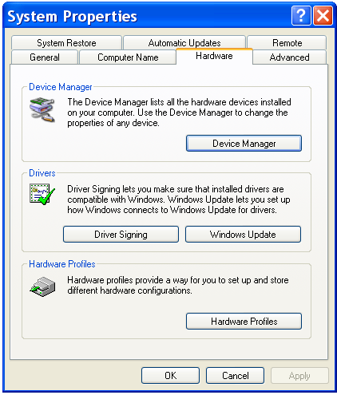

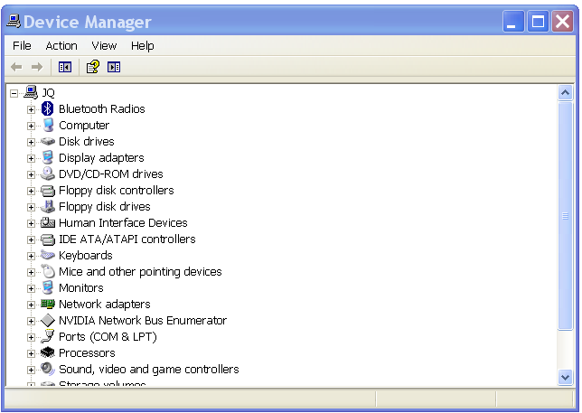

(Hint: you can right-click on any device and see further properties)

1. What is the name of the disk drive?
2. Does the computer have a Bluetooth radio?
3. Does the computer have a network adapter?
4. What is the name of the monitor? Is the proper driver of the monitor installed? What is the name of the provider of the driver for the monitor?
5. Find out the name of your hard disk?

Alternate to the above:

1. Click on windows
2. Go to control panel
3. Click Hardware and sounds
4. Under devices and printers, click device manager